PLAYER DEVELOPMENT SERIES
THE DEVELOPING
POLO PLAYER
A Practical Guide to Riding, Hitting, Tactics
and Game Intelligence
VOLUME I • FOUNDATIONS
Development Edition • September 2026
Prepared for Amir Shafe

Purpose of this book
Polo is not mastered by learning a swing in isolation. A useful player must control a horse at speed, strike accurately, recognize the line of the ball, understand teammates and opponents, and make a safe decision before the play disappears. This book develops those abilities as one connected system.
Volume I establishes the shared language and safety habits on which every later riding, hitting and tactical lesson depends. It is written for beginner-to-intermediate outdoor players, but coaches may also use the drills, checkpoints and observation standards as a structured teaching sequence.
TRAINING PRINCIPLE
Accuracy, balance and awareness come before power. A player who can repeat a controlled action and see the field has a stronger platform for speed than a player who occasionally hits a long ball without control.

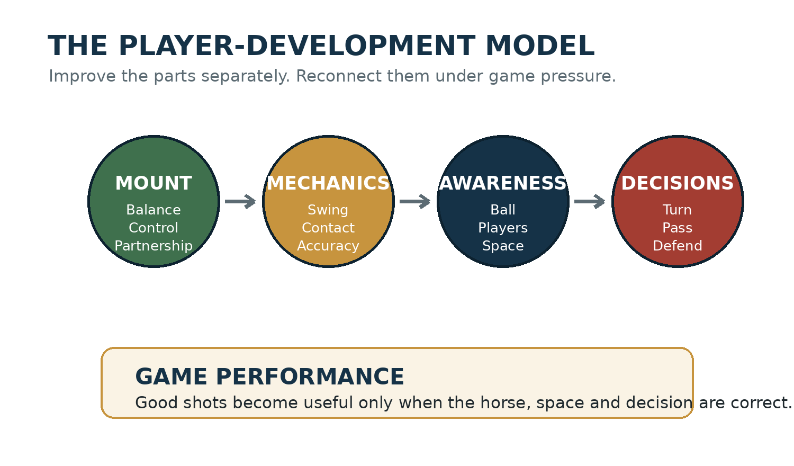
Figure 1. The four domains of development used throughout the book.

How to use each chapter
Element | Purpose
Core lesson | Explains the skill or concept in plain language.
Field picture | Shows the movement, line, angle or space visually.
Coach’s eye | Identifies what an instructor should observe and correct.
Player self-check | Turns the lesson into questions the player can use immediately.
Progressive drill | Moves from low speed and low pressure toward game conditions.
Performance test | Provides a measurable standard before the player progresses.

IMPORTANT SAFETY NOTICE
This guide supplements—but never replaces—qualified mounted instruction, an umpire’s decision, veterinary advice, local club procedures or the current rulebook of the governing association. Horses, field conditions and player experience vary. Stop any exercise when control, footing, tack or spacing becomes unsafe.

Contents
Introduction — From Hitting the Ball to Playing the Game
Part I — Understanding the Game
Chapter 1 — The Character and Origins of Polo
Chapter 2 — The Field, Equipment and Four Positions
Chapter 3 — Safety, Spacing and Field Awareness
Chapter 4 — The Line of the Ball and Right of Way
Part I Development Checkpoint
Appendix A — Player Baseline Assessment
Appendix B — Practice Log
Appendix C — Essential Glossary
Sources and Rulebook Note

INTRODUCTION

From Hitting the Ball to Playing the Game
  - The central transition is from ball fixation to mounted awareness and useful decisions.
A new player experiences polo as a rapidly moving ball surrounded by horses. The natural response is to stare at the ball, chase it and attempt a swing whenever it comes within reach. That response is understandable, but it does not yet amount to playing polo.
A developing player begins to perceive a larger picture. The ball still matters, but so do the line created by its travel, the speed of approaching horses, the location of teammates, the opponent who must be marked, and the open space into which the next play may develop. The player starts acting several seconds earlier.

The development ladder
Stage | What the player notices | Typical limitation | Primary training goal
1. Contact | The ball beside the horse | Looks down and reacts late | Clean, repeatable contact at low speed
2. Control | Horse, reins and ball | Loses balance during the swing | Independent seat and one-handed control
3. Direction | Where the ball should travel | Chooses power over usefulness | Accuracy, angles and controlled backhands
4. Awareness | Other players and available space | Sees the picture only after arriving | Scan before receiving or challenging
5. Decision | What the play needs next | Keeps the ball when a pass or backhand is better | Choose early and commit safely
6. Influence | How movement shapes the whole chukker | Measures value only by touches | Mark, support, protect and create space

The five-point scan
Before the ball reaches the playing area in front of you, briefly identify five things: the ball, its line, the nearest opponent, the most useful teammate, and the open space. The order changes during a chukker, but the habit of widening attention should remain.
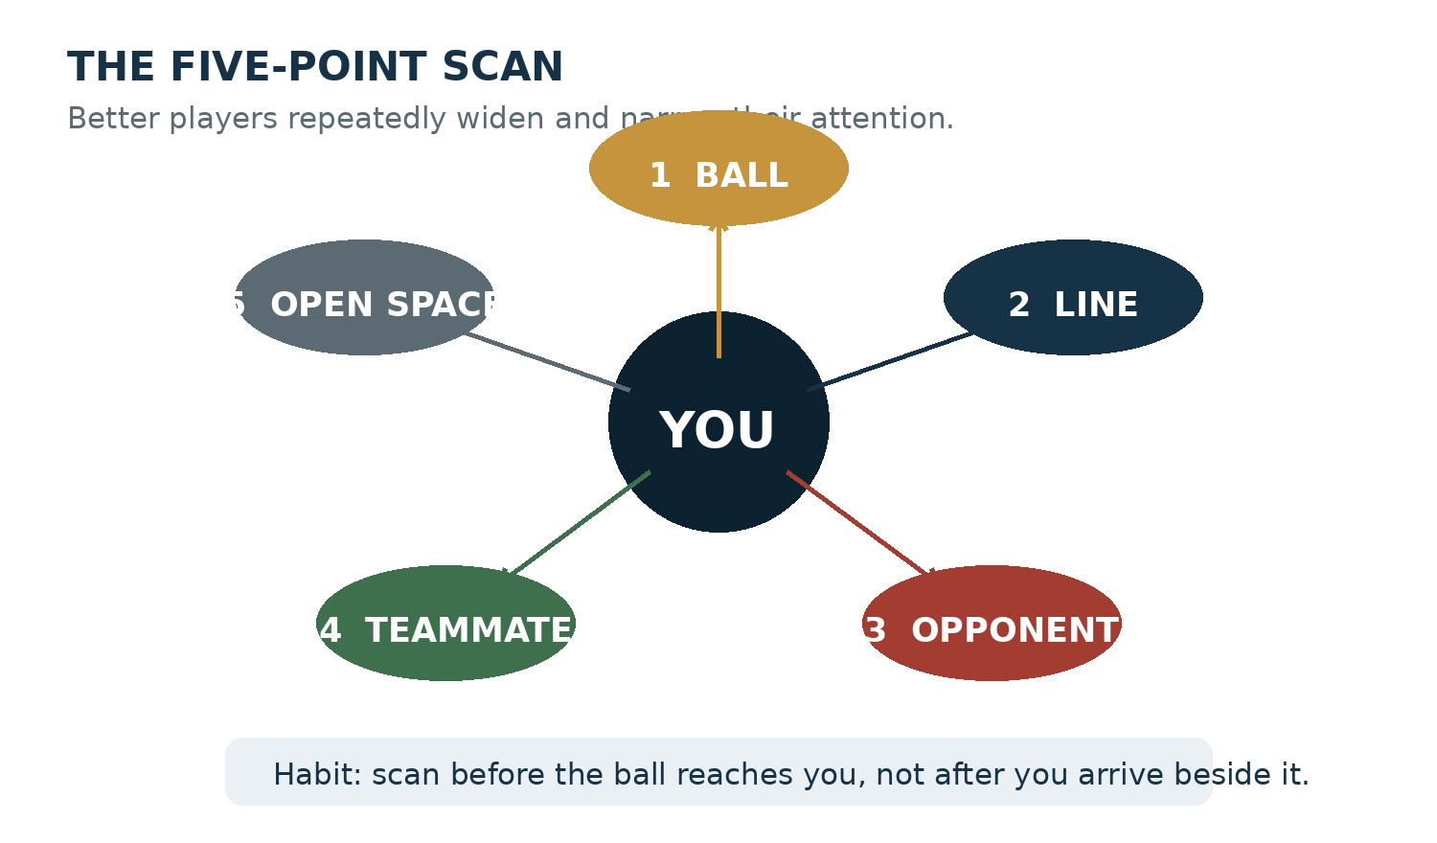
Figure 2. The five-point scan trains the player to see beyond the immediate strike.
PLAYER SELF-CHECK
During the last chukker, how often did you know where your nearest teammate was before you reached the ball? If the honest answer is “rarely,” the next practice objective is scanning—not striking harder.

A better definition of success
A successful practice is not one in which every ball travels far. It is one in which the player can state the objective, repeat the movement, recognize the result and make a useful adjustment. A successful chukker is not measured only by goals or touches; it also includes correct positioning, safe pressure, timely passes, disciplined marking and appropriate horse management.
COACH’S EYE
When reviewing a missed shot, begin five to ten seconds before contact. The decisive error may have been a poor approach angle, late scan, excess speed, loss of line or unnecessary contest—not the swing itself.

First-chukker assignment
Use one practice chukker to establish a baseline. Do not attempt to correct everything while playing. Carry one awareness objective, then review the evidence afterward.
- Before every restart, locate your opposite number and the teammate most likely to receive the next pass.
- Before accelerating toward a loose ball, name the line and identify who is already established on it.
- After the chukker, record one useful decision and one moment when ball fixation narrowed your view.
SUCCESS MEASURE
The objective is not more touches. It is three clearly remembered moments in which looking earlier changed where you rode or what you chose.

PART I
Understanding the Game
Origins, field orientation, safety and the line of the ball.

CHAPTER 1

The Character and Origins of Polo
  - The ancient game explains why modern polo demands coordination between horsemanship, courage, teamwork and strategy.
Polo belongs to a very old family of mounted games. The precise first match cannot be dated with certainty, but historical accounts place early forms among mounted peoples of Central Asia and in ancient Persia. In Persian culture, chogān developed into both a courtly sport and a form of mounted training. Its appeal came from the same qualities players still recognize today: speed, control, cooperation, physical courage and rapid judgment.
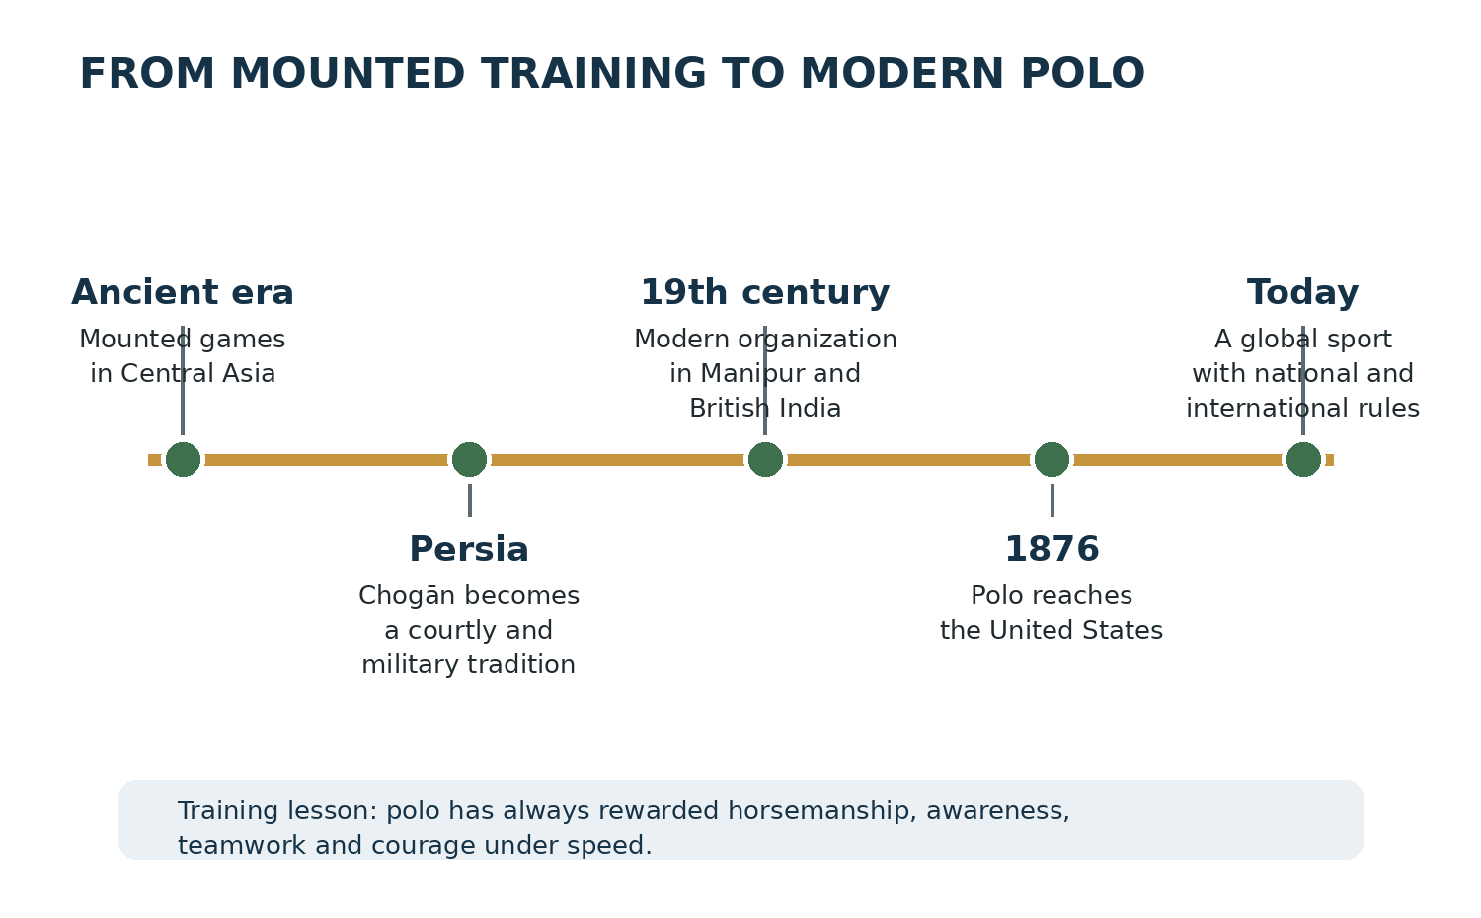
Figure 3. A simplified historical pathway from early mounted games to modern organized polo.

From chogān to the international game
The game spread across cultures and courts, including regions of the Byzantine world, Tibet, China, Japan and the Indian subcontinent. In Manipur, a vigorous local form of the game became the immediate foundation for the modern rules-based sport encountered by British officers and tea planters during the nineteenth century.
The modern international name came through the region where British players encountered the game. They organized clubs and carried standardized forms of polo to Britain and then to many other countries. Polo reached the United States in 1876, and the organization now known as the United States Polo Association was established in 1890 to support and regulate the sport nationally.

Why the history matters to a developing player
Polo’s past is not simply an introductory story. It reveals the game’s underlying logic. A mounted warrior or court player could not focus only on a ball. The rider had to remain balanced, control speed and direction, act in relation to other riders, and continue perceiving a changing field. Modern safety rules now discipline these encounters, but the integrated demand remains.
Historical quality | Modern training expression
Mounted control | Independent seat, one-handed rein control, acceleration and stopping
Spatial awareness | Reading the line, nearby horses, teammates, opponents and open ground
Coordination | Moving as a team rather than four individuals chasing the ball
Courage with restraint | Entering pressure confidently without creating danger
Purposeful striking | Directing the ball into useful space rather than merely hitting hard

TRAINING PRINCIPLE
Polo is a mounted decision game. Hitting is one tool within it—not the whole game.

Reflection drill: watch the game without the ball
- Watch five minutes of a recorded chukker while following only one player, not the ball.
- Record where that player moves when a teammate has possession.
- Identify when the player marks, supports, protects space or prepares for a pass.
- Watch the same sequence again with the ball in view and connect the player’s earlier movement to the eventual play.
PERFORMANCE TEST
Explain, in your own words, why a player can contribute to a goal without touching the ball. Give one attacking and one defensive example.

CHAPTER 2

The Field, Equipment and Four Positions
  - Orientation reduces reaction time: know the ground, the tools and your responsibility before the ball is in play.

The outdoor field
An outdoor polo field is exceptionally large because the game develops at speed and through long changes of direction. Under the USPA framework, a full field may be up to 300 yards long. Width depends in part on whether sideboards are used. Goal posts are eight yards apart. Local fields and tournament conditions may differ, so players should walk or ride the boundaries, goal areas, surface changes and safety zones before play.
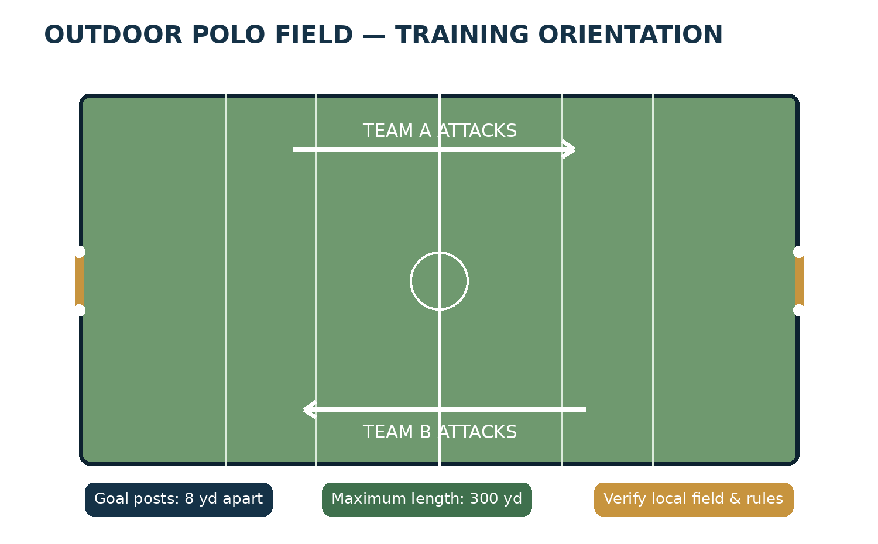
Figure 4. Simplified outdoor field orientation. Diagram is instructional and not a survey drawing.

Read the field before you play
- Locate both goals and confirm the direction your team attacks in the opening chukker.
- Identify boards, boundary markings, uneven ground, wet areas and entry gates.
- Notice wind direction and how it may influence lofted or slowing balls.
- Confirm where horses, grooms, officials, spectators and emergency support are positioned.
SAFETY HABIT
A field inspection is part of playing, not an administrative detail. At speed, a small surface problem becomes a large risk.

Essential player equipment
Item | Purpose | Pre-ride check
Approved helmet | Reduces head-injury risk | Correct fit, secure harness, no visible damage
Knee guards | Protect knees during close mounted contact | Centered, secure and not restricting movement
Boots and heels | Protect lower leg and support stirrup security | Sound sole, appropriate heel and no loose parts
Eye protection | Helps protect against ball, dust and debris | Clear vision, stable fit
Mallet | Transfers the swing into the ball | Sound cane, secure grip and undamaged head
Whites / team shirt | Supports identification and competition requirements | Correct number and local dress compliance

Horse and tack check
The polo pony is the player’s athletic partner. Sound tack and a calm, systematic check protect both horse and rider. The responsible player does not mount and immediately gallop toward the ball.
- Observe the horse standing and walking. Note attitude, soundness and unusual sensitivity.
- Inspect bridle, bit, reins, martingale or breastplate arrangement, girth, saddle, stirrup leathers and irons.
- Confirm leg protection and bandages are secure, correctly tensioned and free of wrinkles or debris.
- Check the tail arrangement and verify nothing can loosen into the mallet or another horse.
- Warm up progressively and confirm steering, stopping and lateral response before joining faster work.
SCOPE NOTE
Tack selection and fitting should be supervised by an experienced polo professional and adapted to the individual horse. This book does not prescribe a single bitting or rigging system.

The four outdoor positions
Outdoor polo normally uses four players per team. Their numbers describe a pattern of responsibilities, but polo is fluid: every player will attack, defend, support and recover. A rigid player becomes separated from the play; a disciplined player changes role while preserving the team’s shape.
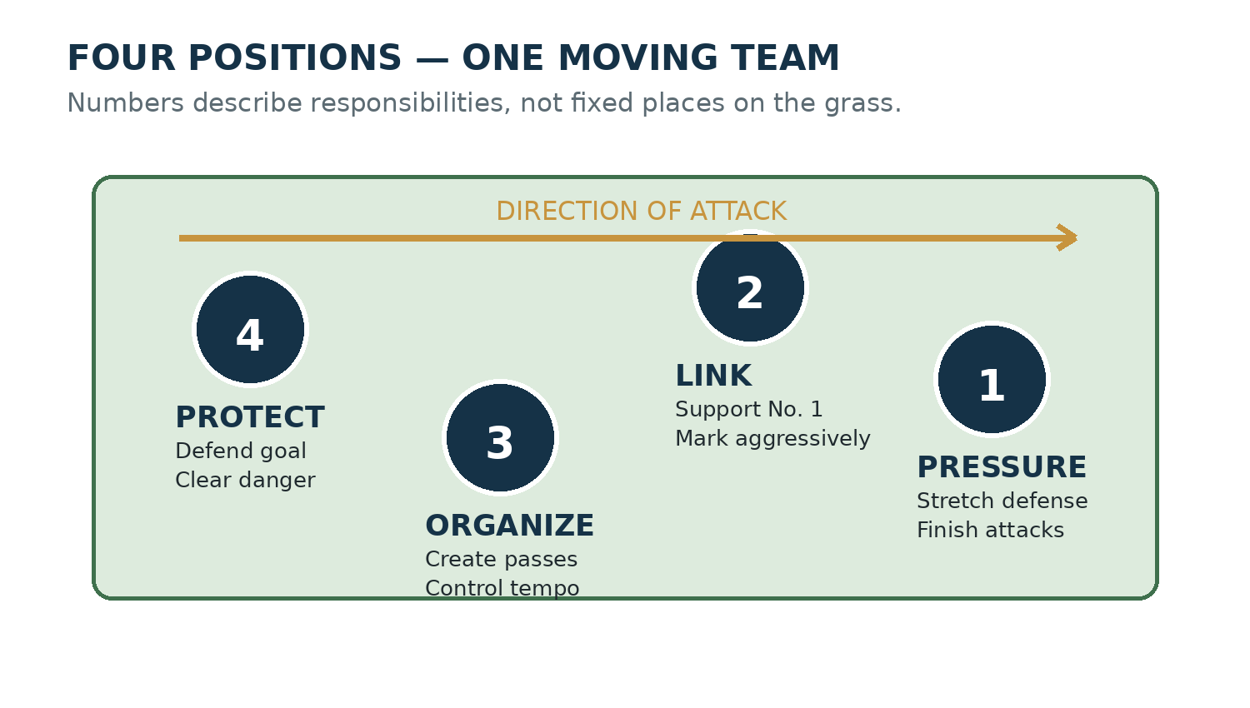
Figure 5. A functional view of the four positions during an attack.
Position | Primary identity | Developing-player priorities
No. 1 | Forward pressure and finishing | Stay available ahead; pressure the opposing back; avoid drifting behind the ball
No. 2 | Aggressive link between attack and defense | Support No. 1; mark a dangerous opponent; use backhands to sustain pressure
No. 3 | Organizer and principal passer | Look up early; control tempo; pass into space; balance attack with recovery
No. 4 | Last defender and clearing player | Protect the goal side; judge risk; clear decisively; avoid unnecessary dribbling under pressure

COACH’S EYE
When all four teammates arrive at the same ball, the problem is rarely effort. It is usually spacing, role recognition or trust.

Walk-through drill: four-player shadow polo
At a walk, use four riders or four people on foot. Move an imaginary ball through three phases: defensive recovery, midfield transition and attack. Freeze every ten seconds. Each participant identifies the nearest opponent, most useful teammate, goal side and next likely space. Resume only when the group can explain its shape.
PERFORMANCE TEST
From any freeze position, name your immediate responsibility in one short sentence: “protect goal side,” “mark No. 3,” “support ahead,” or “offer the pass.” If the answer requires a long explanation, the picture is not yet clear.

CHAPTER 3

Safety, Spacing and Field Awareness
  - Safe polo is active perception: speed, swing, horses and closing space must be judged before contact.
Polo contains real risk: horses travel at speed, players converge, mallets swing through a wide arc and the ball can change direction suddenly. Safety is therefore not a list remembered only after a whistle. It is the way a player approaches, scans, communicates and chooses.

The three zones around a player
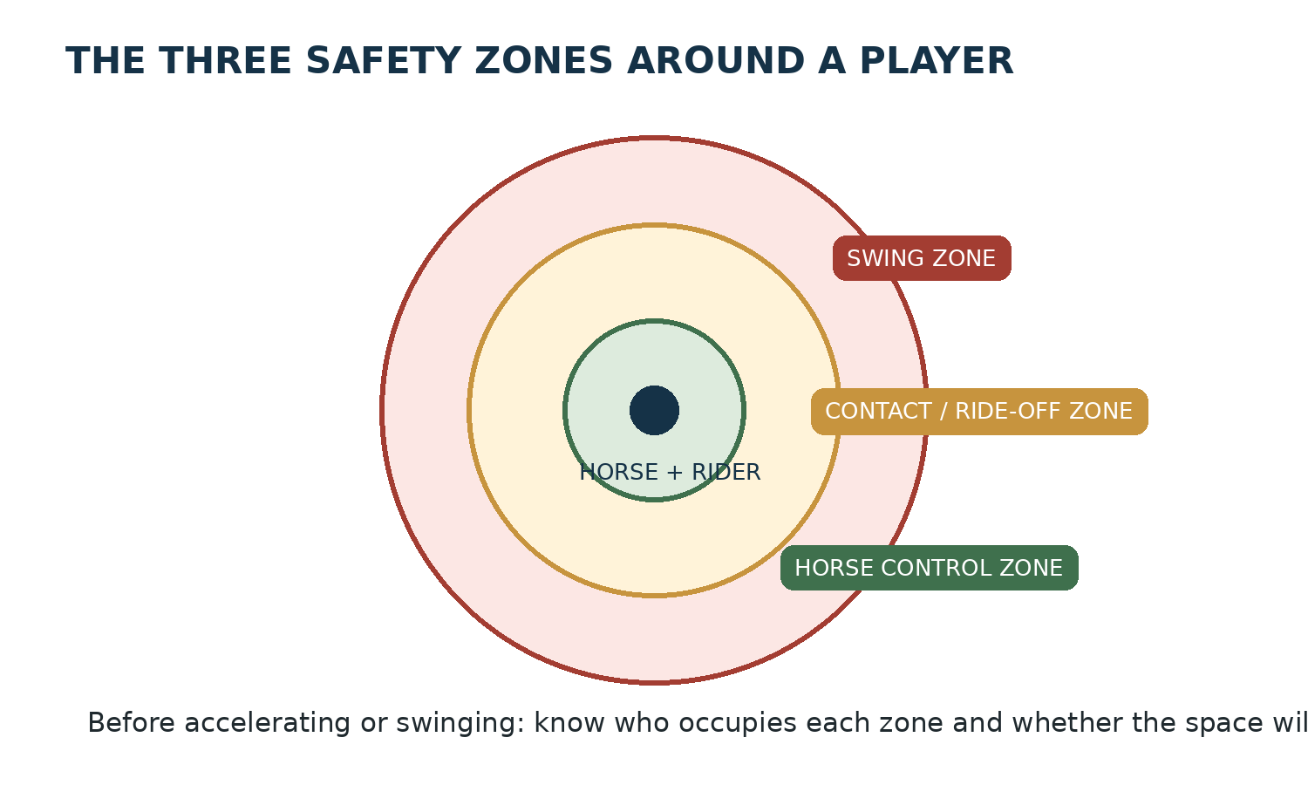
Figure 6. Conceptual safety zones. Their practical size expands with speed and conditions.
The horse-control zone is the space the horse needs to remain balanced, respond and change direction. The contact zone is where matched, legal mounted pressure may occur. The swing zone is the full path of the mallet before, during and after a stroke. These zones are not fixed circles; they expand with speed, a larger swing, poorer footing, less experienced horses and less predictable riders.

Speed changes distance
Two horses that appear comfortably separated at a walk may be only a fraction of a second apart at speed. Developing players often judge distance visually but fail to judge closing rate. Ask not only “How far away is that horse?” but also “How quickly is that distance disappearing?”
Situation | Hidden risk | Safer response
Approaching from opposite directions | Closing speed is the sum of both horses’ speed | Recognize the line early; reduce ambiguity; do not improvise a late crossing
Swinging beside another horse | The follow-through may enter the rider’s or horse’s space | Establish a clear swing zone or choose a shorter, safer play
Accelerating from behind | Front horse may stop, turn or be checked | Preserve reaction distance and choose a parallel approach
Crowding a slow ball | Several riders focus downward and compress space | Look up, communicate and avoid adding another horse to congestion
Turning tightly on poor footing | Horse may lose balance or traction | Open the turn, lower speed and prioritize the horse

Communication is a safety skill
Clear, timely calls help teammates coordinate and alert nearby players to an unfolding play. Calls do not create a right of way, replace the rules or guarantee that another rider can yield. Use them as information, then continue to ride responsibly.
- Call early enough to affect the play; a shout at the moment of collision is not communication.
- Use short, familiar team language and avoid long instructions at speed.
- Never assume a player heard you. Continue to manage distance and direction.

Eyes up without losing the ball
“Look up” does not mean ignoring the ball. It means shifting between focused and wide attention. Track the ball long enough to predict its path, widen attention to identify horses and space, then narrow attention again for contact. This visual rhythm becomes faster with practice.
PRACTICE DRILL — CALL THE PICTURE
At the walk, a coach rolls or places a ball while two teammates and one passive opponent move through the area. Before reaching striking distance, the player must call: “line,” “teammate,” “opponent,” and “space,” pointing or naming each. Strike only after the scan is complete.

If control is deteriorating
Players sometimes continue because they feel pressure not to interrupt a drill or chukker. Good judgment is the opposite: if the horse is not responding normally, tack has shifted, visibility is impaired, footing has worsened, or the rider is physically compromised, leave the play in a controlled way and obtain help.
STOP CONDITION
Do not continue a mounted exercise when you cannot reliably regulate speed, steer away from another horse, maintain your seat, or keep the mallet under control.

Performance test: awareness before contact
Complete ten controlled approaches at a walk or slow trot. Before each strike, correctly identify the intended line, nearest horse, open escape route and target. The standard is eight complete scans without losing steering or striking into occupied space.

CHAPTER 4

The Line of the Ball and Right of Way
  - The line organizes safe access to the ball; it is a moving relationship, not permanent ownership.
RULEBOOK NOTE
This chapter teaches a practical safety model based on the USPA concept of the line of the ball and right of way. Exact rulings depend on the current rulebook, the full field picture and the umpire. Arena rules and other national associations may differ.

What is the line of the ball?
Whenever the ball travels, imagine a line extending through its path both forward and backward. The most recent stroke or deflection establishes a new line. Even a small change in the ball’s direction can change the line and therefore change how players may safely approach.
The line is not a painted lane and it does not belong forever to the player who last touched the ball. It is a device for organizing converging horses. Right of way arises from the relationship between the line, the direction of travel, proximity, speed and the position of other players.

A safe approach
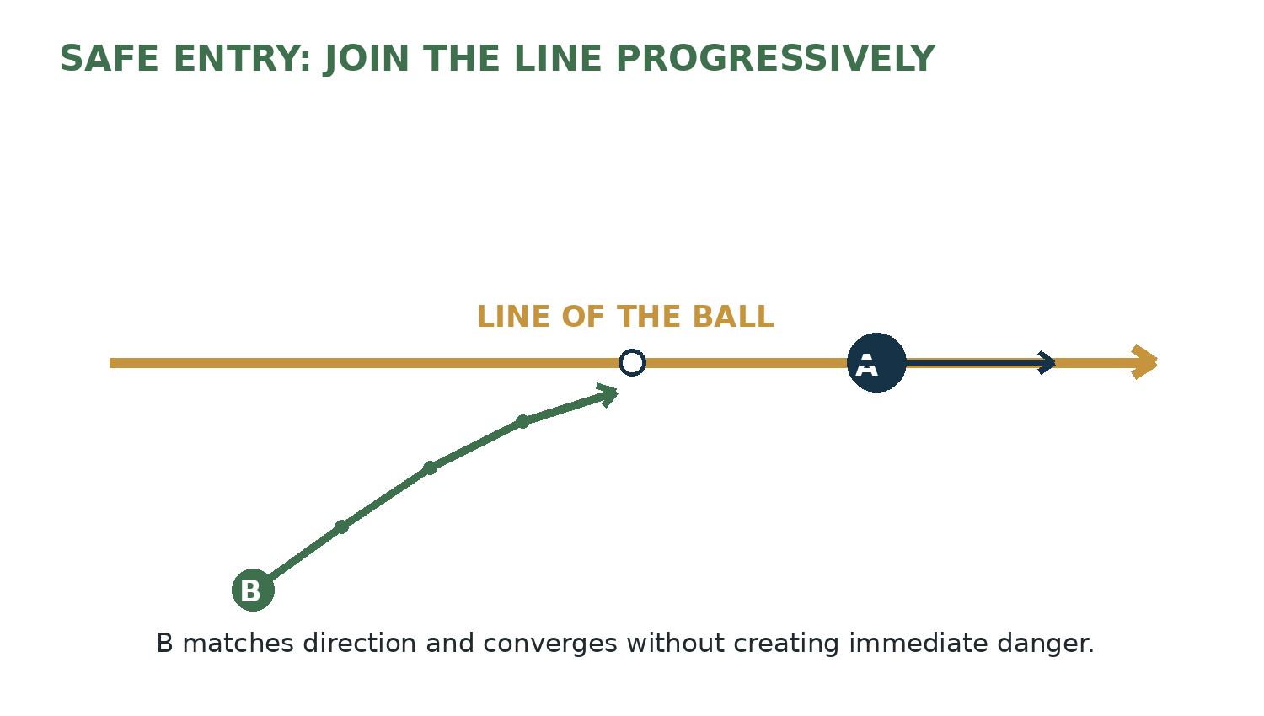
Figure 7. A progressive entry reduces the crossing angle and allows speed to be matched.
A player joining the play should generally reduce the angle of convergence, match the direction of the line and avoid forcing the player already established on it to check or deviate. The earlier the entry begins, the more time every horse and rider has to understand the picture.

A dangerous crossing
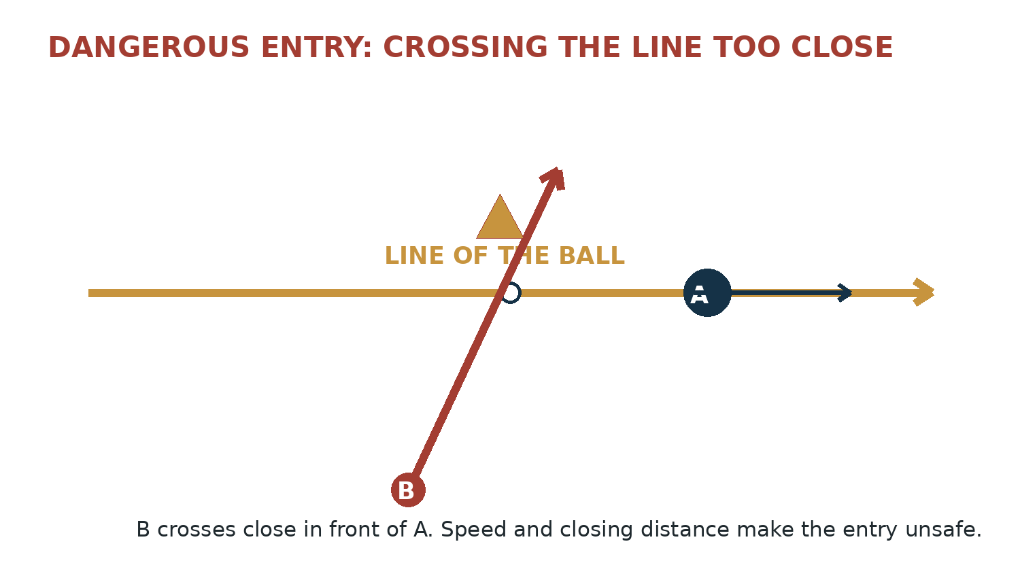
Figure 8. A late, close crossing creates immediate danger even if the crossing rider believes the ball is reachable.
A common beginner error is to calculate only whether the mallet can reach the ball. The correct question is whether the horse and rider can enter without creating danger. If another player must slow, pull away or change line abruptly to avoid contact, the entry was not made safely.

Four questions before challenging
- What is the current line, including any recent deflection?
- Which player is already established closest to that line and in what direction?
- What is the closing speed between the horses?
- Can I join, ride off or play the ball without causing the established player to avoid me?
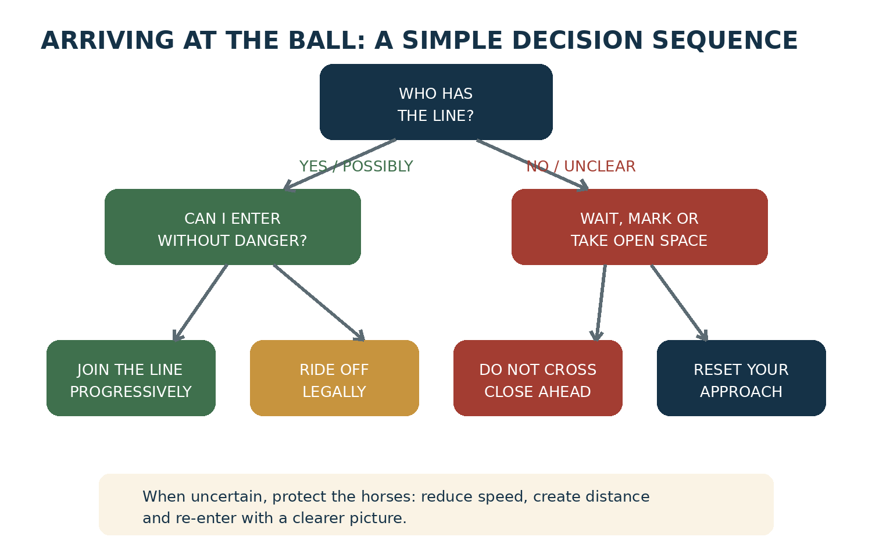
Figure 9. A simplified decision sequence for approaching a contested ball.

The line can change instantly
Suppose Player A travels along the existing line. The ball hits a divot, pony or mallet and turns sharply. The old mental picture is no longer reliable. Every nearby player must update the line before accelerating into the new path. Experienced players appear quick partly because they revise the picture sooner—not because they always ride faster.
COACH’S EYE
Freeze video immediately after every strike or deflection. Ask the player to draw the new line and identify the first two horses affected. This teaches recognition at the moment the picture changes.

Ride-offs and the line
A legal ride-off can help a player gain access to the ball while the horses travel in compatible directions and at comparable speed. It should be produced through controlled horse position and shoulder-to-shoulder pressure, not by striking, dangerous angle, excessive disparity of speed or uncontrolled upper-body force. Instruction must begin at the walk with suitable horses and a qualified coach.
Better picture | Danger signal
Horses travel in nearly the same direction | One horse approaches across the other’s path
Speeds are matched before contact | A faster horse arrives suddenly from an unseen angle
Rider remains balanced over the horse | Rider leans or pushes in a way that compromises control
Pressure develops progressively | Impact is abrupt or intended as a collision
Both players preserve a playable line | One horse is forced into another horse, boards or unsafe ground

Walking line drill
- Place a ball and mark its imagined line with two rows of cones extending forward and backward.
- Player A walks on the line toward the ball without striking.
- Player B begins at a shallow angle and progressively joins the direction behind or alongside, as instructed.
- Repeat with wider starting angles, but require the player to reduce the angle well before proximity becomes unsafe.
- Add a gentle ball roll. Both players call “new line” whenever direction changes.
PROGRESSION RULE
Do not add speed until both riders repeatedly identify the line, regulate closing distance and abort an unclear entry without prompting.

Part I performance standard
During three recorded practice chukkers, identify every situation in which you approached a contested line. For each, classify the choice as: joined safely, rode off under control, waited and repositioned, crossed with unnecessary risk, or arrived without a clear picture. The initial goal is not zero mistakes; it is accurate recognition and a declining number of unclear approaches.
Choice | What good evidence looks like
Join | Angle narrows early; direction and speed become compatible.
Ride off | Contact is progressive, balanced and does not create a collision.
Wait / mark | Player gives up an unsafe challenge but remains useful to the next play.
Reposition | Player creates a clearer future approach instead of forcing the current one.
Abort | Player recognizes uncertainty and protects both horses before proximity becomes dangerous.

PART I CHECKPOINT
Understanding Before Speed
A player who can explain the picture is ready to practice it more deliberately.

Knowledge and awareness checkpoint
- ☐ I can identify the direction of attack and the important field boundaries before play.
- ☐ I can describe the responsibilities of all four outdoor positions.
- ☐ I inspect my equipment and participate responsibly in the horse-and-tack check.
- ☐ I can describe the swing, contact and horse-control zones around a player.
- ☐ I scan for the ball, line, opponent, teammate and open space before arriving.
- ☐ I redraw the line after a strike or deflection.
- ☐ I understand that reaching the ball does not automatically make an entry safe.
- ☐ I can choose to wait, mark or reposition when the approach is unclear.
READY TO PROGRESS
Move into mounted hitting mechanics only when the player can maintain basic horse control while scanning and can recognize unsafe line entries at low speed.

APPENDIX A

Player Baseline Assessment
  - Record the starting point honestly; improvement becomes visible only when it is measured.
Domain | Baseline observation | Score 1–5 | Next priority
Independent balance | Maintains position while turning shoulders and reaching
One-handed control | Regulates speed and direction without abrupt rein use
Offside contact | Produces clean, repeatable contact at controlled speed
Nearside confidence | Approaches and swings without collapsing or steering across
Ball direction | Sends the ball toward an intended gate
Scanning | Identifies players and space before contact
Line recognition | Updates the line after each change of direction
Decision quality | Chooses turn, pass, backhand, mark or wait appropriately
Positioning | Preserves team spacing and role responsibility
Horse management | Warms up, regulates effort and reports concerns

Scoring guide: 1 = unfamiliar; 2 = requires continuous instruction; 3 = functional at low pressure; 4 = repeatable in practice chukkers; 5 = reliable under game pressure. Scores are developmental observations, not handicaps.

Interpret the baseline
Do not average the ten scores into a single judgment. Polo development is constrained by the weakest safety-critical domain. A player with strong contact but unreliable horse control or line recognition should prioritize the weaker domain before adding pressure or speed.
- Select one horse-control priority, one hitting priority and one awareness priority.
- Write a visible behavior for each priority—for example, “scan before the final three strides,” not “improve awareness.”
- Reassess after four to six purposeful sessions using the same conditions where practical.
DEVELOPMENT RULE
Scores guide practice allocation; they are not a substitute for a handicap, competition evaluation or coach’s judgment.

APPENDIX B

Practice Log
  - Turn each ride into evidence: one objective, one observation and one next action.

Session 1
Field | Entry
Date / horse / conditions
Single training objective
Drill and number of repetitions
Best repeatable result
Main error pattern
What happened before the error?
Next-session adjustment

Session 2
Field | Entry
Date / horse / conditions
Single training objective
Drill and number of repetitions
Best repeatable result
Main error pattern
What happened before the error?
Next-session adjustment

Session 3
Field | Entry
Date / horse / conditions
Single training objective
Drill and number of repetitions
Best repeatable result
Main error pattern
What happened before the error?
Next-session adjustment

APPENDIX C

Essential Glossary
  - A shared vocabulary allows players, coaches and umpires to discuss the same picture.

Field and flow
Term | Working definition
Boards | Low sideboards used on some outdoor fields to help keep the ball in play.
Chukker | A period of play; duration and competition format are governed by the applicable rules.
Chogān | Historic Persian name associated with polo and the polo stick.
Hook | A defensive use of the mallet to block or interfere with an opponent’s swing when permitted and safe.
Line of the ball (LOB) | The imaginary line created by the ball’s path, extended forward and backward.
Nearside | The horse’s left side.
Offside | The horse’s right side; the usual side for the basic forehand in polo.

Shots, contact and rulings
Term | Working definition
Open backhand | A backhand directed away from the horse and generally toward the side of the field.
Penalty | A prescribed restart or free hit awarded after a foul, according to the applicable rules.
Ride-off | Controlled mounted pressure used to move an opponent from a line or play, subject to safety rules.
Right of way (ROW) | The protected path that arises among players near the ball according to the line, direction, proximity and rules.
Tail backhand | A backhand directed behind the horse, often across the field or toward teammates.
Turn | A maneuver used to remain with or reverse onto the ball; it must respect the line and other players.

Sources and rulebook note
The historical and rules-oriented portions of this development edition were checked against the following institutional sources. The reader should always consult the most current rulebook and local tournament conditions before play.
United States Polo Association — Rules and 2026 Rulebook: uspolo.org/sport/rules
United States Polo Association — Association History: uspolo.org/association/history
Museum of Polo and Hall of Fame — History of Polo: polomuseum.org/history-of-polo
Federation of International Polo — International organization and rules resources: fippolo.com
EDITION CONTROL
Rules checked: September 1, 2026. Training language should be reviewed whenever the applicable association publishes rule changes.

Next volume
Volume II will develop the mounted platform: the polo seat, one-handed control, acceleration and stopping, shoulder independence, approach lines, and the progressive mechanics of the offside forehand and backhand.

